STEP 1  Arrive at Center | 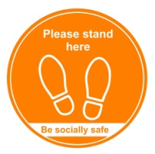  Arrive at the Center's front door and find a placement marker on the sidewalk to wait.
STEP 2  Line up on “X” | 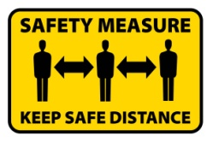  Proceed to the Center's Check In station by  moving from one marker to the next.  Remain 6ft distance.
STEP 3  Take home shoes | 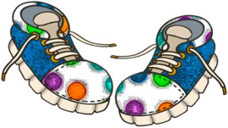  Remove your child's shoes, take them  with you and bring back for pick up.
STEP 4  Temperature Check | 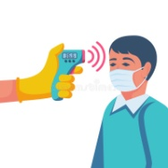  Our Check In greeter will take your child's  temperature and your temperature.  If your child has a fever they will  be sent home.
STEP 5  Drop-off  your child | If your child is fever-free our Center "runner"  will take your child to their classroom.
STEP 6  Sign in pick-up information | 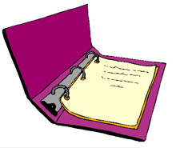  At the Check In table we will record:  Your contact information and pickup  information for the afternoon
See you this afternoon | All information has been recorded, we  will see you at pick up this afternoon!
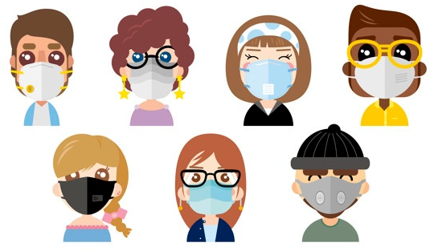
Please Note: Masks are required at all times for all adults and children 2 years and older
Thank you!

