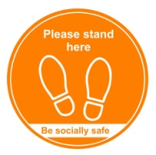  STEP 1  Arrive at Center | Arrive at the Center's front door and  find a placement marker on the  sidewalk to wait.
STEP 2  Line-up on “X” | 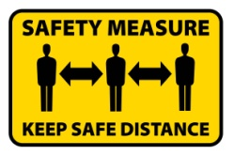  Proceed to the Center's Check In  station by moving from one marker  to the next. Remain 6ft distance.
STEP 3  Bring shoes  from home | 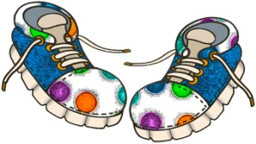  Bring your child's home shoes to  change into.
STEP 4  Sign-out  your child | 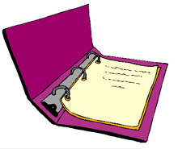  Our Check In greeter will sign your child out.
STEP 5  Pick up  your child | Our Center "runner" will pick up  your child and bring them to you.
See You Tomorrow | We will see you tomorrow!

